**Problem:**

Thescreen belowis the output from a calculator program.

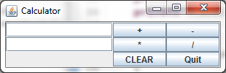

1. Write the necessary code to create the GUI using the appropriate components and Layout Manager(s). Note there is a JLabel beside the Clear JButton that displays the result.
2. Add event handling to the program so that when the user clicks the **Clear** button both the JTextFields and the JLabel are cleared of data.
3. Write the code for all operations**, plus**, **minus**, **divide**, and **multiply**. Assume the data entered is a double. Use anonymous inner classes for the event handling.
4. If the user enters non-numeric data or nothing in the JTextFields a NumberFormatException is thrown. Deal with this Exception and use JOptionPane to display appropriate message as shown in screen shot below.

